Infosys Springboard Virtual Internship 7.0
Completion Report
_________________________________________________________________________________

Batch Number 01 : Enterprise Learning Platform with Skill and Career Guidance System
Start date : 29-06-2026

Name: Nakka Rajeev
Internship Duration: 40-day ( 12 Weeks )

1. Project Title

Enterprise Learning Platform with Skill and Career Guidance System

2. Project Objective

Enterprise Learning Platform with Skill and Career Guidance Systemis an all-in-one platform designed to bridge the gap between learning a skill and becoming job-ready. The main objectives of this project are:

Interactive Learning & AI Chatbot Support: To provide students with an in-app AI assistant powered by Google Gemini for real-time doubts resolution and course guidance.

Personalized AI Learning Roadmaps: To generate tailored, step-by-step skill acquisition paths based on individual learner goals and current knowledge levels.

Skill Gap Analysis & Career Readiness: To evaluate student capabilities against target industry roles and highlight exact missing competencies.

Hands-on Assessment & Digital Certification: To offer automated quizzes, instructor-graded assignments, and verifiable digital completion certificates.

Resume Building & Gamification: To generate job-ready resumes automatically from learner profiles and incentivize engagement using leaderboards, points, and digital badges.

Role-Based Enterprise Dashboards: To deliver distinct interfaces for Students (learning & progress), Instructors (course creation & grading), and Admins (platform oversight & analytics).

3. Project description in detail
The Enterprise Learning Platform with Skill and Career Guidance System is a full-stack web application built with a modern React 19 + Vite frontend, a robust Spring Boot 3.5 (Java 17) backend, a MySQL relational database, and Google Gemini AI integration. The system consists of multiple interconnected modules:
Landing Page & Hero Section:
- Introduces platform capabilities, highlights core features (AI Roadmaps, Course Catalog, Career Tools), and guides users to register or log in.
Authentication & Authorization System:
- Provides secure user onboarding with JWT (JSON Web Tokens) and Google OAuth2 single sign-on. Implements Role-Based Access Control (RBAC) across STUDENT, INSTRUCTOR, and ADMIN roles.
User Dashboards:
- Student Dashboard: Displays enrolled courses, completion percentages, upcoming assignments, earned badges, and recent activity logs.
- Instructor Dashboard: Allows creation of new courses, lesson uploads, assignment reviews, and student analytics tracking.
- Admin Panel: Provides platform-wide management tools for user account moderation, course approvals, system health, and engagement metrics.
AI Assistant & Roadmap Generator (Google Gemini API):
- AI Roadmap Generator: Synthesizes custom learning paths by analyzing requested skill domains, dividing them into weekly milestones with recommended resources.
- AI Chatbot Assistant: Embedded floating widget providing instant contextual answers, code debugging help, and study advice.
Course Catalog & Practice Modules:
- Features categorized video/text lessons, interactive practice exercises, auto-graded quizzes, and project assignment submissions.
Career Tools (Skill Gap Analysis & Resume Builder):
- Skill Gap Analyzer: Compares user profile skills against industry standards.
- Resume Builder: Automatically compiles learner bio, completed courses, certified skills, and projects into a professional PDF/downloadable resume.
Community Forum & Gamification:
- Threaded discussion board for Q&A and upvoting. Gamification engine powered by points, streak tracking, and leaderboard rankings.

4. Timeline Overview
Week | Activities Planned | Activities Completed
Week 1 | Project objective is decided, making github repository | Github repository created, finalizing teams with the project overview
Week 2 | Tech stack evaluation, architecture planning | Spring Boot & React setup completed, learning about REST APIs
Week 3 | Setup user authentication, JWT tokens | Done with verified signin | login with JWT sessions & OAuth2
Week 4 | Learning about API’s, setting api’s for project, database design | API’s is setup using Gemini AI, OpenAI etc.  which makes project effective
Week 5 | LMS pipeline development – course hierarchy, content mapping | Tiered course catalog (Basecamp, Ridge, Summit) implemented
Week 6 | Spring Boot service logic, repository interfaces | Implementing service layer functions and MySQL JPA mappings
Week 7 | Gemini AI integration, prompt template design | Used Gemini models for live AI assistant & code tutor in Enterprise Learning Platform
Week 8 | Quiz assessment, assignment portal development | Automated quiz scoring and assignment upload portal completed
Week 9 | Gamification system - XP, badges, leaderboards | Displayed leaderboards, XP points, and user badges based on activity

Week 10 | Dark/Light theme switch, UI polishing | Theme toggle working across UI, modern glassmorphism aesthetic
Week 11 | Dashboard design (like user activity, streak, profile, feedback) | Implementing dashboard with different course tiers and activity heatmap
Week 12 | Adding career suite (ATS Resume, digital certs, admin panel) | Project fully tested and ready for evaluation

5a. Key Milestones
Milestone | Description | Date Achieved
Project Kickoff | Defined the project objectives, scope, system architecture, and responsibilities for developing SkillSphere platform. | 29 Jun 2026
Prototype / First Draft | Developed initial working prototype including Spring Boot backend, basic UI pages, and core course input functionality. | 08 Jul 2026
Mid-Term Review | Evaluated project progress, improved dashboard design, integrated Gemini AI model, and refined LMS functionality. | 23 Jul 2026
Final Submission | Completed the fully functional SkillSphere system including dashboard analytics, AI chatbot, gamification, and certs. | 13 Aug 2026
Final Presentation | Demonstrated the working system highlighting features such as skill tracking, AI roadmaps, chatbot, and architecture. | 02 Sep 2026
5b. Project execution details
- Requirement Analysis: Identified pain points in online learning platforms and defined functional specs for courses, AI roadmaps, skill gap analysis, and role-based permissions.
- System Architecture Design: Adopted a decoupled client-server architecture with React handling client-side rendering and Spring Boot serving stateless REST APIs.
- Database Architecture & Design: Built a relational MySQL database utilizing Spring Data JPA and Hibernate for entities including Users, Courses, Lessons, Enrollments, Quizzes, Certificates, and Badges.
- Backend REST API Development: Implemented Spring Boot controllers and service layers with global exception handling, DTO mapping, and input validation.
- Security & Authentication Implementation: Secured endpoints using Spring Security, JWT authentication filters, password hashing (BCrypt), and Google OAuth2 integration.
- Frontend UI Development: Built responsive UI components using React 19, React Router v7, custom CSS modules, and Context APIs for Auth and Theme state.
- Gemini AI Service Integration: Integrated Google Gemini API for natural language prompt processing to generate structured JSON learning roadmaps and real-time chatbot responses.
- Career & Gamification Tools: Developed algorithms for skill gap matching against career roles, automated PDF resume generation, and dynamic leaderboard calculation based on earned XP.
- Role-Based Dashboard Creation: Separated user workflows into Student, Instructor, and Admin views with specialized analytics cards and data tables.
- Testing, Optimization & Build: Performed cross-browser verification, API postman testing, backend unit testing, and production packaging using Maven and Vite.

6. Snapshots / Screenshots
Opening the project folder containing all the main files such as ServerApplication.java, SecurityConfig.java, controllers, services, App.jsx, and components in VS Code.
1. Opening the main backend and frontend application source files in VS Code to view the full-stack code.
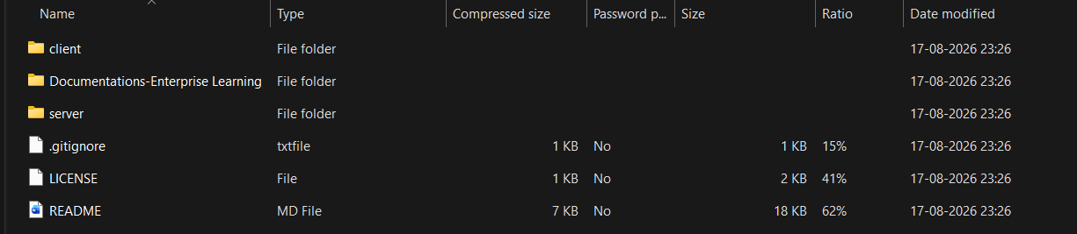
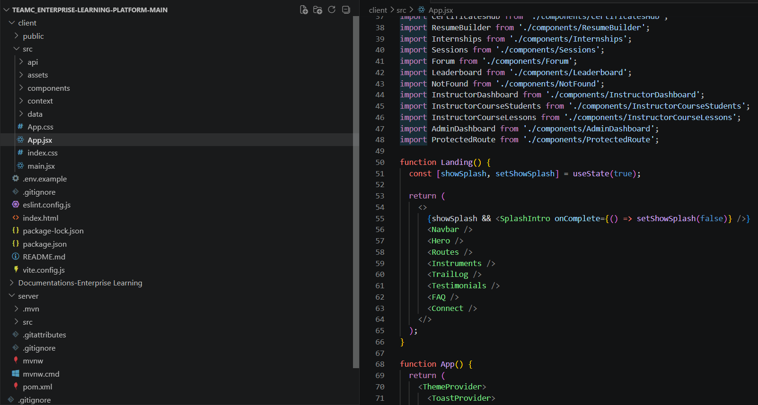
- Running the application in the terminal of VS code (./mvnw spring-boot:run and npm run dev).

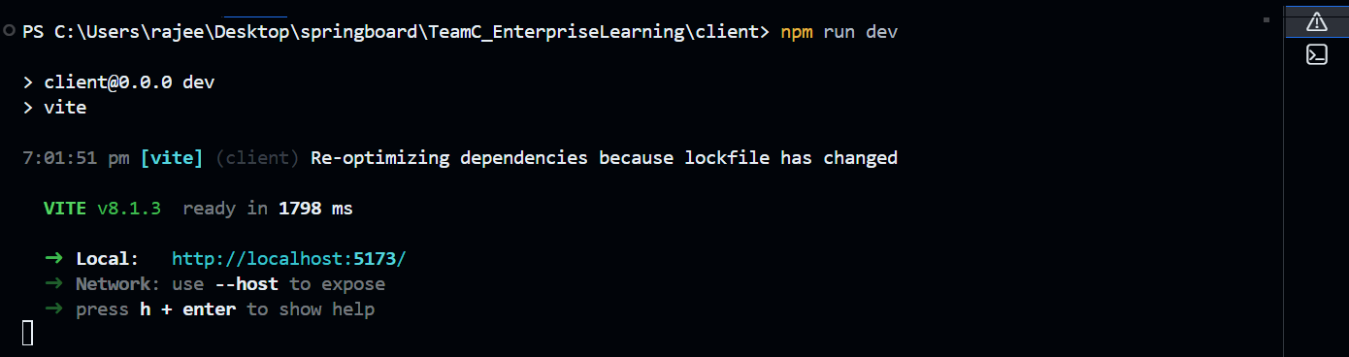

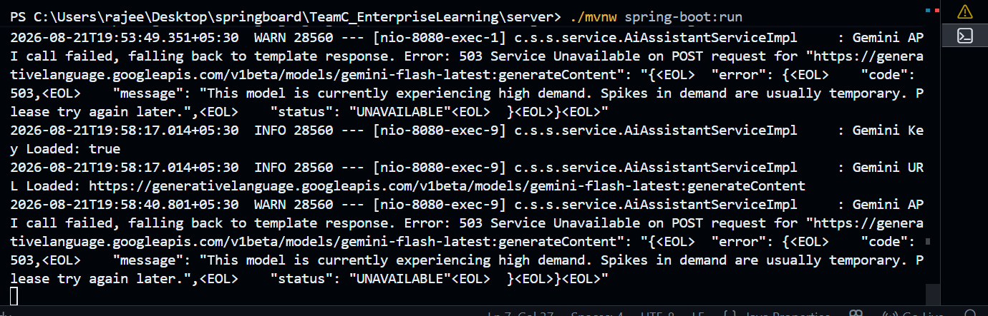

- Copying or clicking the local server link provided by Vite (http://localhost:5173 / http://localhost:8080). The home page of the Enterprise Learning Platform appears on the browser.

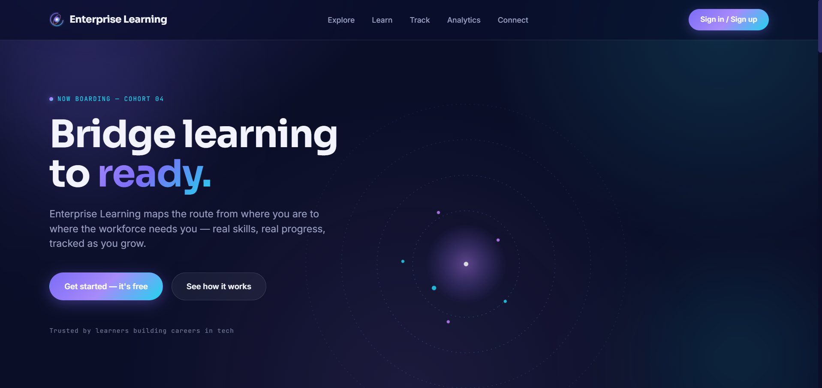
Figure 1: Landing Page Interface
LANDING PAGE

- Next page includes log in and also create an account for the new user or you can start your account with google also.

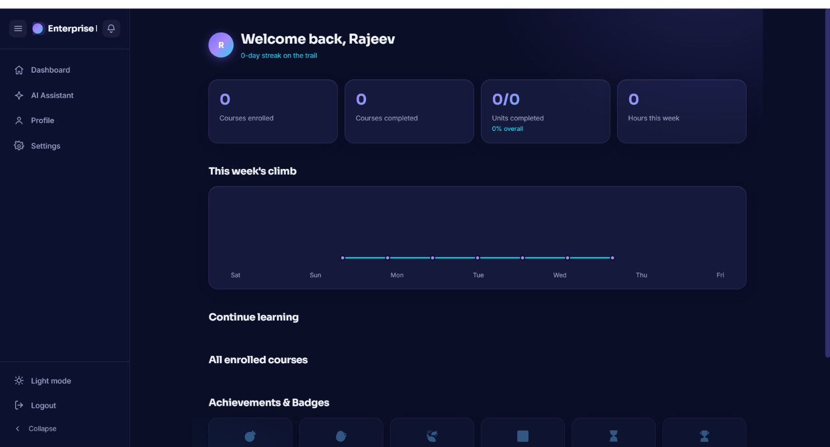
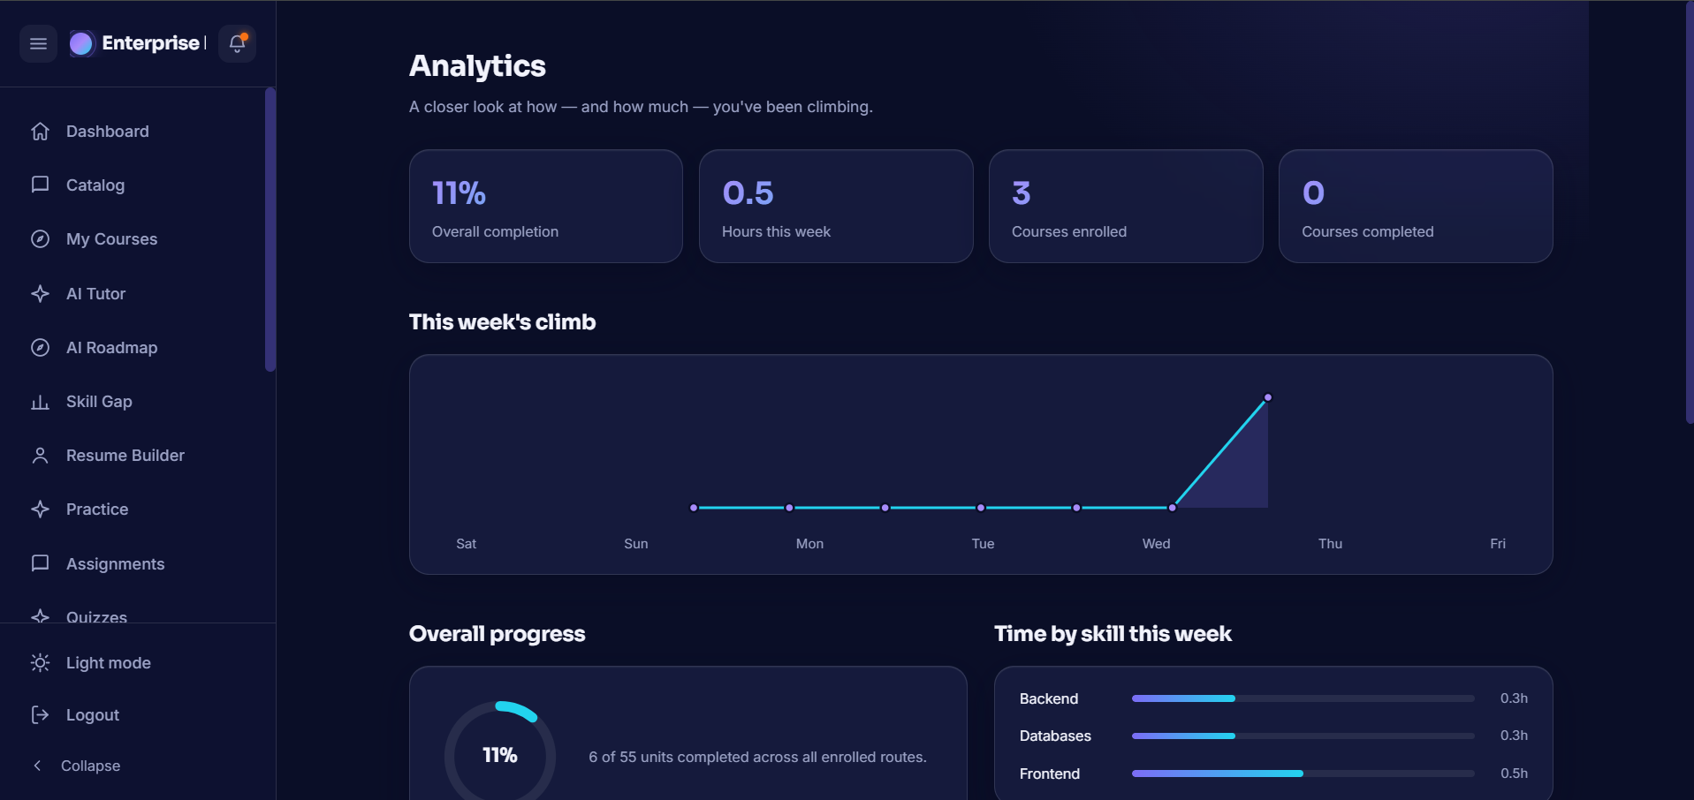
Student Analytics & Learning Dashboard Interface

- Chatting with AI tutors and code assistants is also available in the application.

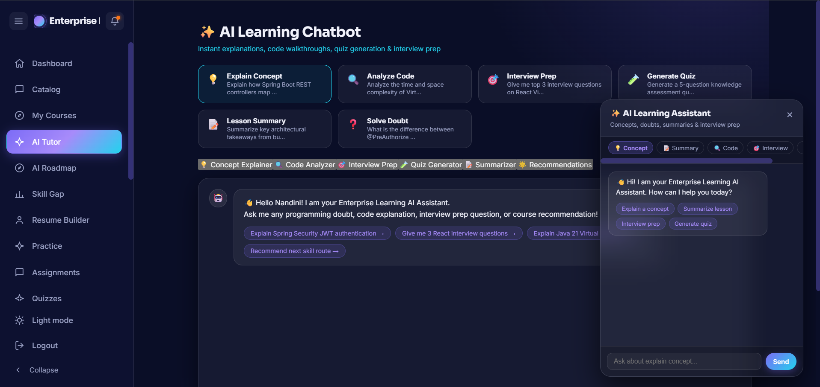
AI Assistant & Code Complexity Analysis Interface

7. Challenges Faced
- Spring Boot & React CORS & Security Configuration: Configuring Spring Security to permit pre-flight CORS requests while retaining JWT validation across stateless REST endpoints required careful security filter chain orchestration.
- Google Gemini AI API Integration & Output Formatting: Handling unstructured natural language AI responses and reliably parsing them into structured JSON arrays for step-by-step roadmaps required specialized prompt engineering and fallback parsing logic.
- Complex Relational Database Schema Design: Mapping multi-way relationships between Users, Courses, Enrolments, Quizzes, Submissions, Badges, and Certificates in MySQL via Hibernate without causing N+1 query performance bottlenecks.
- Google OAuth2 Redirect & JWT Token Exchange: Seamlessly bridging Google OAuth2 social login with custom JWT session tokens to ensure unified user profile creation and role assignment.
- State Management in React 19: Managing global authentication states, active user context, dark/light UI themes, and dynamic notifications without unnecessary component re-renders.
- Role-Based Access Control (RBAC): Restricting specific routes and backend APIs based on student, instructor, and admin authority levels across client-side routes and server-side annotations (@PreAuthorize).
- Auto-Grading & Certification Engine: Developing reliable auto-grading calculation for quizzes and triggering verifiable certificate generation upon 100% course progression.
- System Integration & Cross-Platform Verification: Ensuring frictionless communication between Vite development server, Spring Boot backend, MySQL database, and external Gemini endpoints during full integration.

8. Learnings & Skills Acquired
- Java & Spring Boot Framework: Gained deep expertise in building scalable RESTful microservices, dependency injection, JPA/Hibernate ORM, and Spring Security architecture.
- React 19 & Modern Frontend Development: Mastered component-driven UI architecture, custom hooks, React Router v7 navigation, and state management in Vite environment.
- Database Management (MySQL & SQL): Developed proficiency in schema design, indexing, foreign key constraints, complex joins, and Spring Data JPA repository specifications.
- Artificial Intelligence Integration: Learned how to prompt engineer, authenticate, and process Google Gemini API responses into web application features.
- Web Security & Authentication: Understood modern security practices including password hashing (BCrypt), JWT creation/validation, and OAuth2 workflow execution.
- RESTful API Design: Mastered designing clean, standardized REST APIs using proper HTTP verbs, status codes, DTO patterns, and global exception handlers.
- UI/UX Design & Styling: Enhanced skills in crafting responsive, accessible, dark/light themed user interfaces with smooth CSS transitions.
- Agile Collaboration & Version Control: Mastered Git feature-branch workflows, pull request code reviews, issue tracking, and collaborative full-stack development.

9. Testimonials from team

Nandini Verma (Frontend UI Lead):
“Designing and implementing the responsive UI in React 19 for the Enterprise Learning Platform with Skill and Career Guidance Systemwas an incredibly rewarding experience. Integrating dynamic dashboards, course views, and theme toggling enhanced my practical frontend skills immensely.”

Rahul (Backend & API Architect):
“Architecting the Spring Boot REST backend allowed me to apply clean enterprise design patterns. Building robust service layers, custom DTOs, and global exception handlers significantly strengthened my backend engineering capabilities.”

Rajeev (Database Specialist):
“Designing the MySQL database schema and mapping complex entity relationships with Spring Data JPA gave me valuable hands-on insight into database optimization, data integrity, and efficient querying.”

Sasi Madhuri (Authentication & Security Engineer):
“Implementing end-to-end security using Spring Security, JWT stateless tokens, and Google OAuth2 was a great challenge that deepened my understanding of web application security standards.”

Madhumitha (AI & Deployment Strategist):
“Integrating Google Gemini AI into the platform to generate custom learning roadmaps and an interactive chatbot brought real innovation to the project. It demonstrated how AI can transform modern digital education.”

10. Conclusion
The Enterprise Learning Platform with Skill and Career Guidance Systemproject successfully demonstrates the seamless convergence of full-stack enterprise web development and generative artificial intelligence. By combining a React 19 frontend, Spring Boot 3.5 backend, MySQL database, and Google Gemini AI, the platform offers a complete end-to-end learning lifecycle — taking students from skill assessment and personalized AI roadmaps to hands-on practice, gamified engagement, and job-ready resume generation. The project highlights how modern technology can bridge educational gaps and empower learners with intelligent, personalized career preparation.

11. Acknowledgements
We express our sincere gratitude to Infosys Springboard for providing an excellent learning environment, industry-oriented curriculum, and access to comprehensive resources that made the development of the Enterprise Learning Platform with Skill and Career Guidance System possible.
We extend our heartfelt thanks to Ms. Shakthi Gopalakrishnan, our mentor, for constant guidance, technical feedback, and continuous encouragement throughout the project development lifecycle. The insights provided played a vital role in refining our system architecture, security standards, and overall project implementation.

